**FX Rates Integration**

Trigger the below job from control-M and validate the file in NAS.

Control M Job : FMSGB_P_NZL_OIC_02AD  
Run Control : OIC_ANZ_GEN_EXTR_FXRT_D1

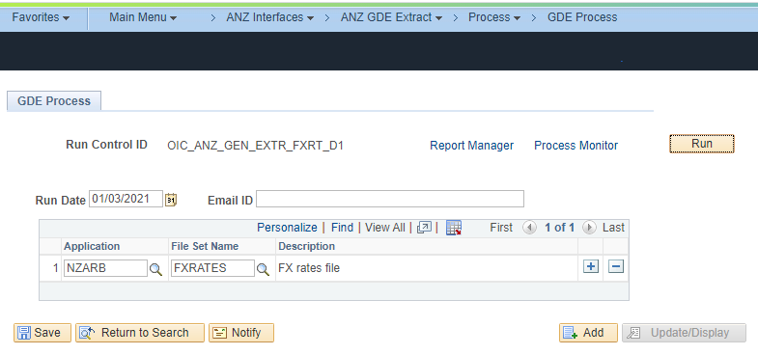

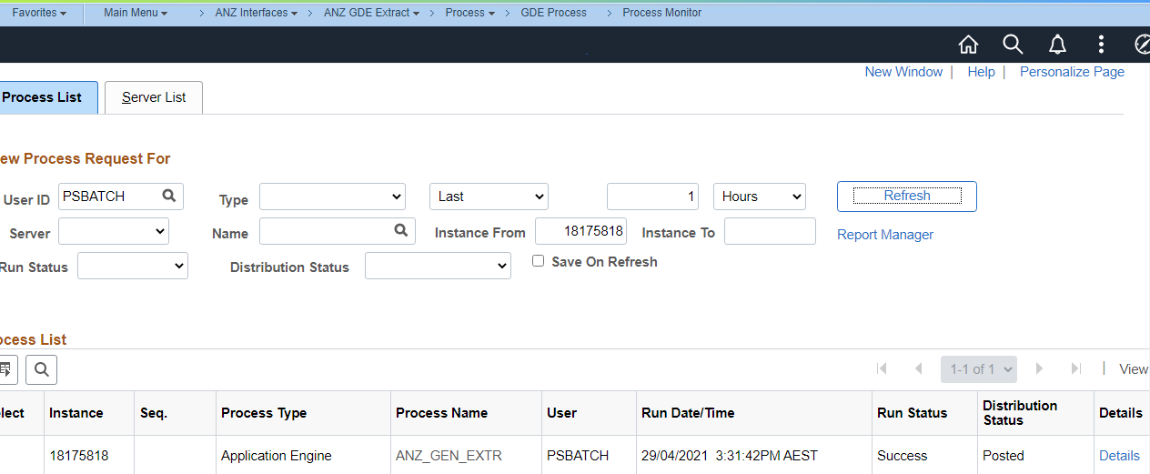

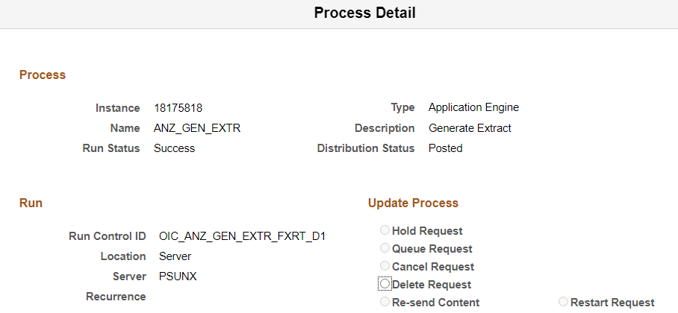

Files generated in the below specified NAS.

